Scope of Work for Tax Map Key (TMK): (1) 2-2-010:021 Nuuanu
The table below contains the State’s current estimate of the schedule and significant dates. All times are Hawaii Standard Time (HST). If a component of this schedule, such as "Bid quotes Due Date and Time" is delayed, the rest of the schedule may likely be shifted by the same number of days. Any change to the IFB Schedule and Significant Dates prior to the bid quote due date shall be issued by addendum.
Event | Date
Solicitation Release: | 7/20/2026
Question Submittal Deadline: | 7/27/2026, 4:00 P.M.
Answers to Questions: | 7/28/2026, 4:00 P.M.
Bid quote Due Date and Time: | 7/30/2026, 2:00 P.M.
Evaluations | 7/30/2026 – 7/31/2026
Estimated Date for Discussions, if necessary | TBD
Estimated Due Date for BAFO, if necessary | TBD
Anticipated Award Date: | 7/31/2026 2:00 P.M.

*Supporting documentation must be either uploaded to HIePRO or submitted to darlene.bryant@hawaii.gov.

C. Scope of Work: Located on TMK:122010021.

- One (1) tree at the entrance to Honolulu Myohoji Mission at 2003 Nuuanu Ave.

  - The work consists of removing the whole tree, leaving behind only a 2 ft. height stump to retain and deter soil erosion. Do NOT use stump treatment herbicide on the remaining stump. The single tree has many multiple tree limbs at the base remove all. Shown in Exhibit – A and Exhibit – A1.

  - There is a single branch that has broken-off from the tree and fell onto the adjacent tree; please Remove just that branch. Shown in Exhibit – B1.

  - Contractor must clean work area of tree debris from the work, also clean road entrance of debris.

  - All cut branches and debris must be removed and disposed off-site at an authorized facility.

- Two trees at the back of private property at 1928 Pauoa Rd.

  - Trim and cut back branches shown in Exhibit I, Exhibit II, Exhibit III,
and Exhibit IV. Tree branches are over hanging into the neighboring property. (Access to the area may/will need to be granted by the homeowner in the adjacent property to use driveway. TMK: (1) 2-2-010:016.)

D. General Notes:

- During the duration of the project, there shall be one (1) qualified arborist certified by the International Society of Arboriculture (ISA Certified Arborist) supervising the job.
- All work to be done during the hours of 8:00AM to 4:30PM, Monday – Friday. Exceptions can be requested in writing to ODLO, But will not be effective unless approved.
- Work may not proceed without an authorized Notice to Proceed (“NTP”) letter/email or purchase order from the ODLO.
- The Contractor shall be responsible for verifying the location of all utilities and structures. Any damage, injury, and/or loss to any property resulting from the performance of the work shall be the sole responsibility of the Contractor and shall be remedied promptly by the Contractor at their own expense.
- The Contractor will be provided contact information for the sites to coordinate physical access to the site, if needed.
- The Contractor shall provide safety signs, barricade, and other devices necessary for the safety and convenience of the general public.
- The Contractor shall observe all applicable Federal, State, and Municipal acts, statutes, ordinance, and rules pertaining to the performance of this job.
- The bid award shall be based on the availability of funds.
- Submission of bid shall be the evidence that the Contractor understands the scope of the job description herein.

Exhibits are shown below:
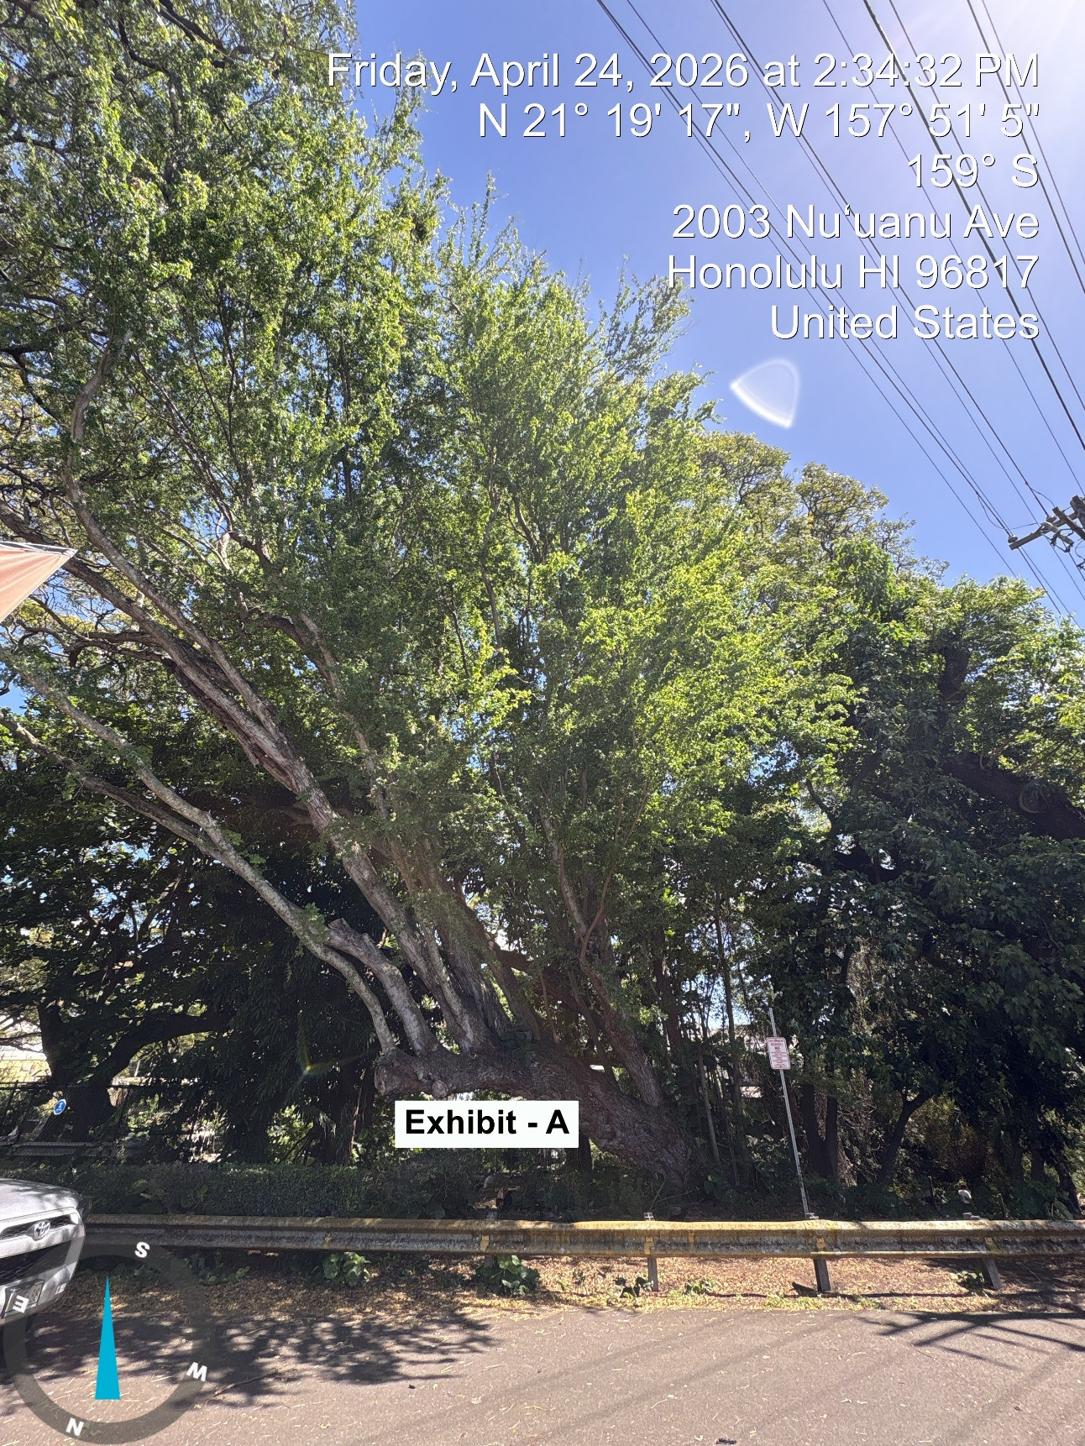
Exhibit - A
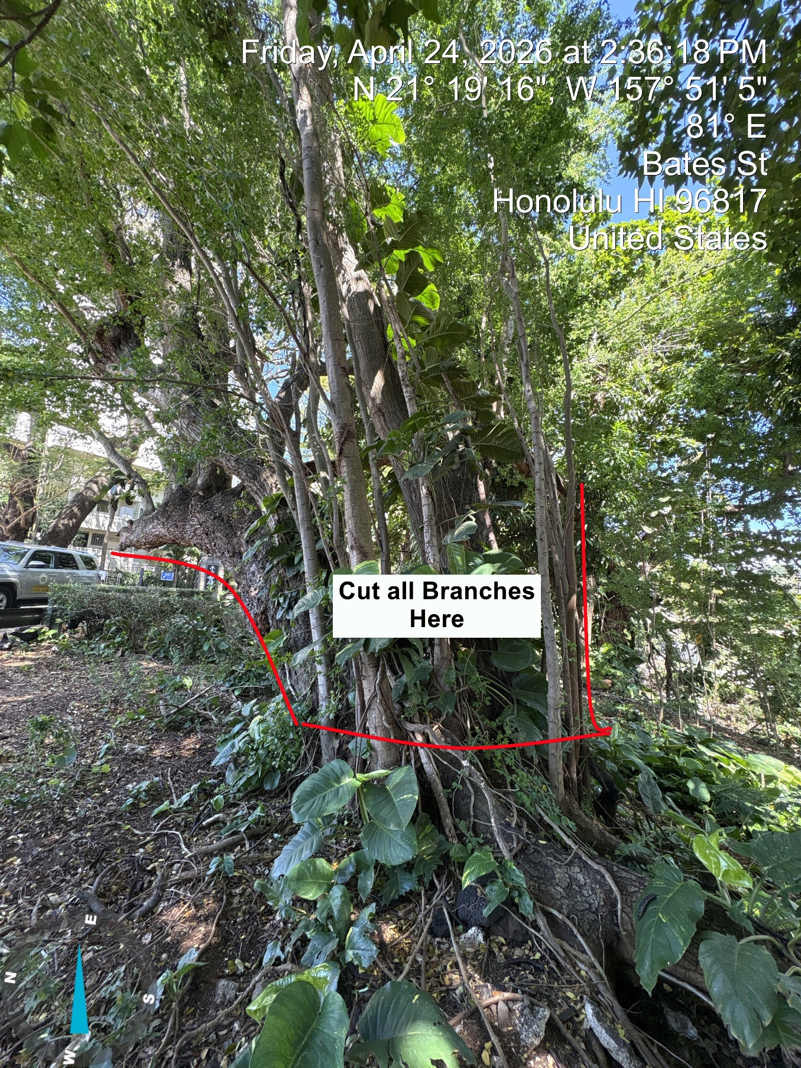
Exhibit – A1
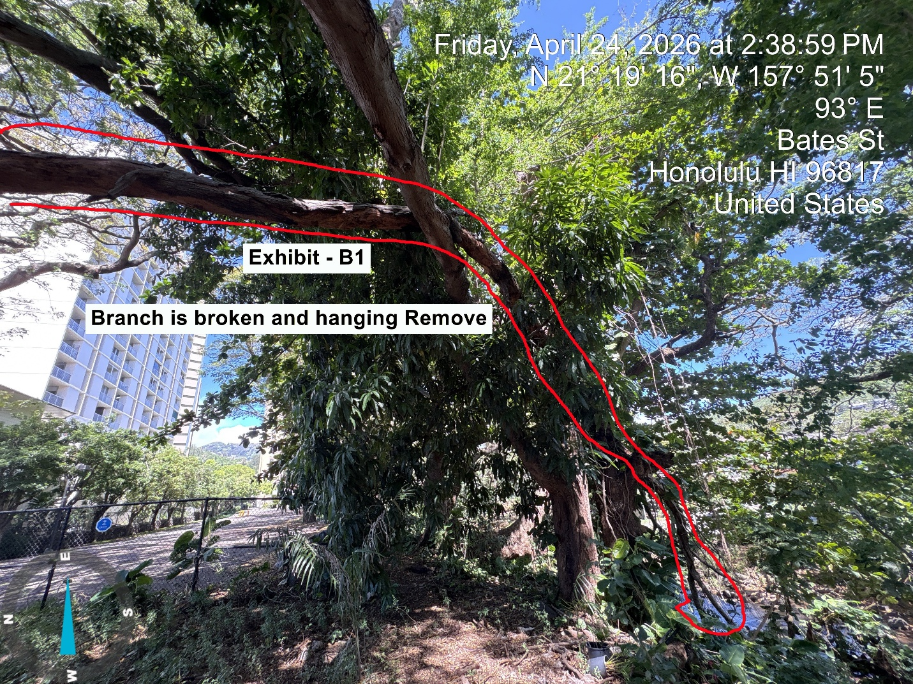
Exhibit – B1

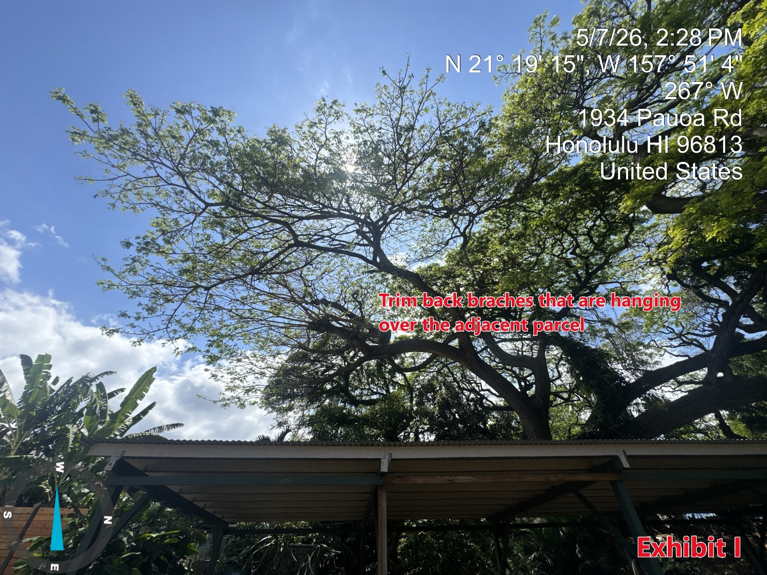
Exhibit I

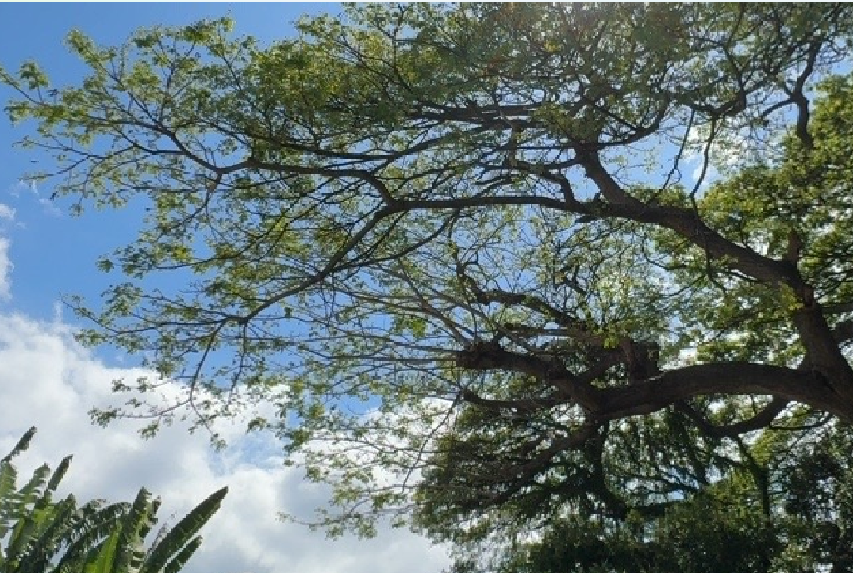
Cut branches off at red line

Exhibit II
EXHIBIT II
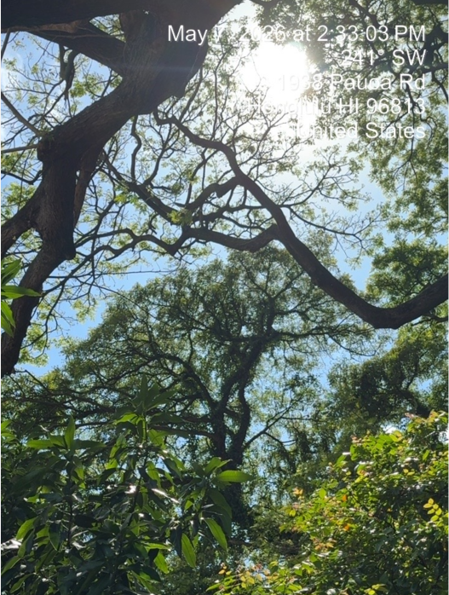
Cut branch at base of tree.
EXHIBIT III

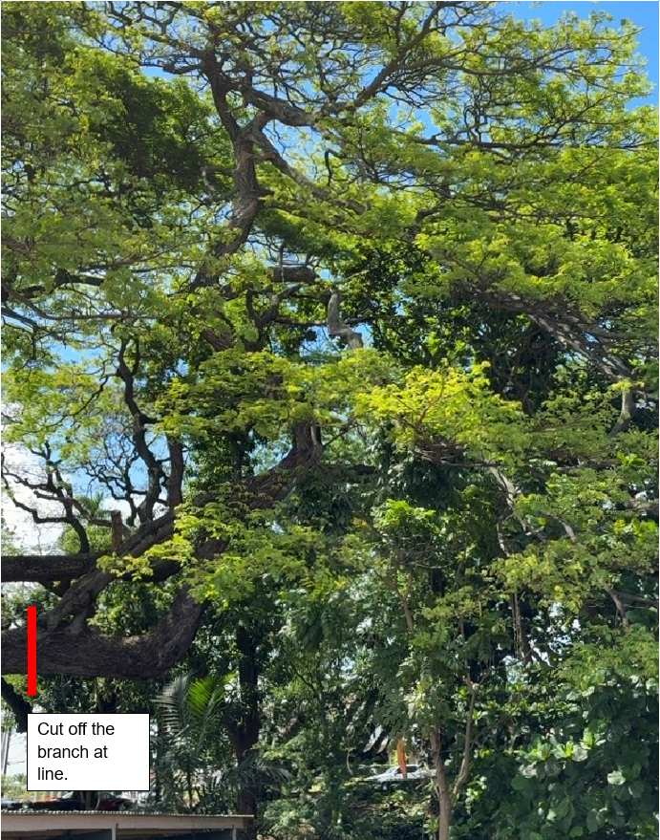
EXHIBIT IV

